Project Design Phase-II
Data Flow Diagram &amp; User Stories
Date | 19 February 2026
Team ID | LTVIP2026TMIDS35300
Project Name | Civil Engineering Insight Studio
Maximum Marks | 4 Marks

Part-1: Data Flow Diagrams (DFD)

DFD Level 0
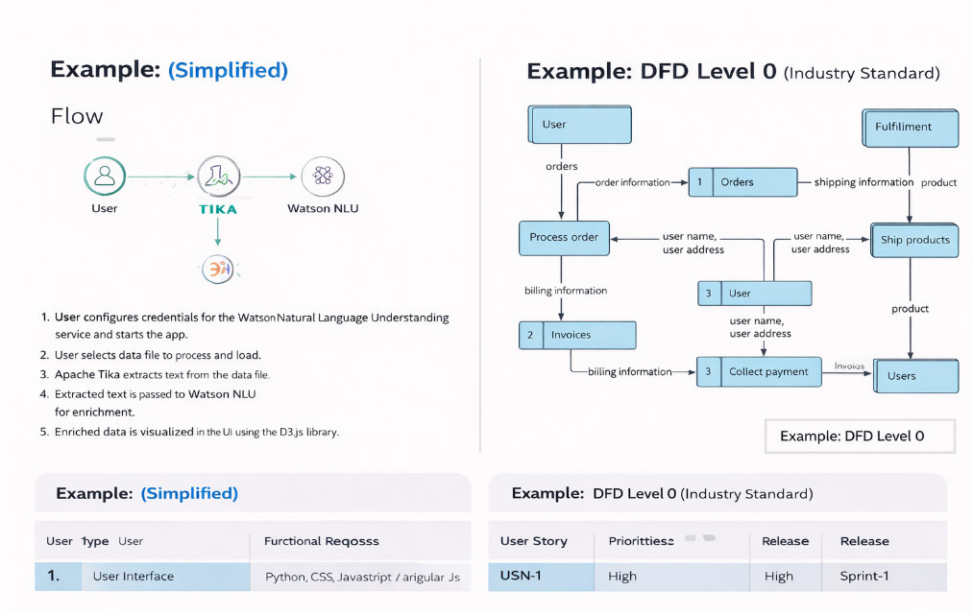

DFD Level 1 (Detailed Flow)

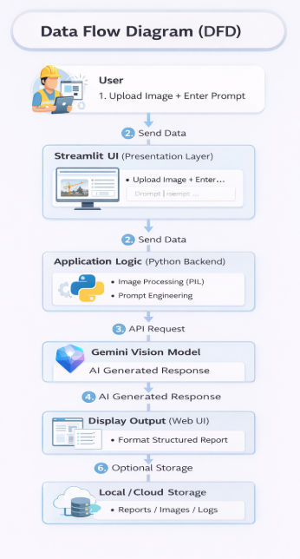

Part-2: User Stories

User Types
- Civil Engineer (Web User)
- Project Manager
- Administrator

User Stories Table
User Type | Functional Requirement (Epic) | User Story Number | User Story / Task | Acceptance Criteria | Priority | Release
Civil Engineer (Web User) | Image Upload | USN-1 | As a civil engineer, I can upload a construction site image for analysis | I can successfully upload JPG/PNG images | High | Sprint-1
Civil Engineer (Web User) | Prompt Input | USN-2 | As a user, I can enter a text prompt describing what analysis I need | I can type and submit a prompt successfully | High | Sprint-1
Civil Engineer (Web User) | AI Analysis | USN-3 | As a user, I can receive a detailed structural description after submission | The system generates structured output with materials, components, and insights | High | Sprint-1
Civil Engineer (Web User) | Material Detection | USN-4 | As a user, I can identify construction materials from the image | Materials such as concrete, steel, and bricks are listed in the response | High | Sprint-1
Project Manager | Progress Monitoring | USN-5 | As a project manager, I can analyze project progress from site images | The response includes completed and planned elements | High | Sprint-1
Project Manager | Report Generation | USN-6 | As a manager, I can generate a structured report from the AI output | The report is displayed in a clear, structured format | Medium | Sprint-2
Administrator | System Monitoring | USN-7 | As an admin, I can monitor application usage and API performance | Usage logs and system performance data are accessible | Medium | Sprint-2
Administrator | API Management | USN-8 | As an admin, I can securely manage API keys and configurations | API key stored securely in environment variables | High | Sprint-1
Civil Engineer | Error Handling | USN-9 | As a user, I receive an error message if no image is uploaded | System shows warning when image is missing | High | Sprint-1
Project Manager | Documentation Storage | USN-10 | As a manager, I can store generated reports for future reference | Reports are saved locally or in cloud storage | Medium | Sprint-2

